***Assignment – 11* Subqueries.**

1. Write a query that uses a subquery to obtain all orders for the customer named Cisneros. Assume you do not know his customer number (cnum).

**select O.onum,O.amt,O.odate from Orders O where O.snum=(select snum from Customers where cname="Cisneros");**

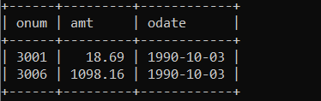

1. Write a query that produces the names and ratings of all customers who have above-average orders.

**select c.cname ,c.rating from Customers c where c.cnum In(select distinct o.cnum from Orders o where o.amt>(select avg(amt) from Orders));**

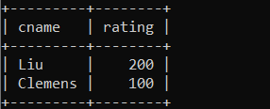

1. Write a query that selects the total amount in orders for each salesperson for whom this total is greater than the amount of the largest order in the table.

**select s.sname,sum(o.amt) as Total From Salespeople s Join Orders o On s.snum=o.snum Group by s.snum,s.sname Having sum(o.amt)>(select max(amt) from Orders);**

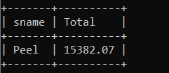

*Sameer Dehadrai* Page: 1